**Exercise_No:14**

**Date:23-11-2020**

**Aim:**

**To print the output for the given problem using python.**

**Program:**

**def areBracketsBalanced(expr):**

**stack=[]**

**open_expressions=['{','[','(']**

**for i in range(len(expr)):**

**if(expr[i] in open_expressions):**

**stack.append(expr[i])**

**else:**

**if not stack:**

**return False**

**curr=stack.pop()**

**if(curr=='{' and expr[i]!='}'):**

**return False**

**if(curr == '['and expr[i]!=']'):**

**return False**

**if(curr == '(' and expr[i]!=')'):**

**return False**

**if stack:**

**return False**

**else:**

**return True**

**if __name__ == "__main__":**

**expr=input()**

**if(areBracketsBalanced(expr)):**

**print("valid")**

**else:**

**print("invalid")**

**Link:**

[**http://103.53.53.18/mod/vpl/forms/submissionview.php?id=327&userid=1684#**](http://103.53.53.18/mod/vpl/forms/submissionview.php?id=327&userid=1684#)

**Output:**

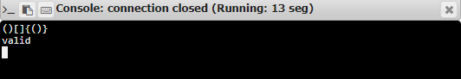

**Result:**

**Thus, the output for the program is successfully executed.**